THE TIMES Sept 7 1840
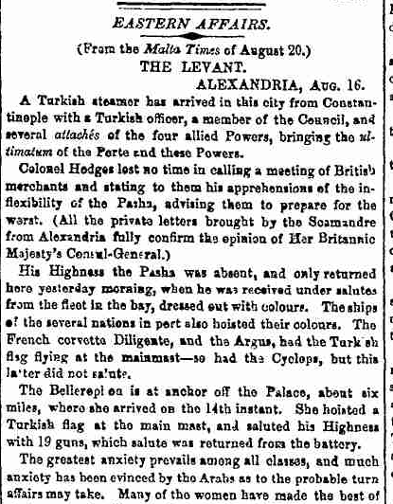
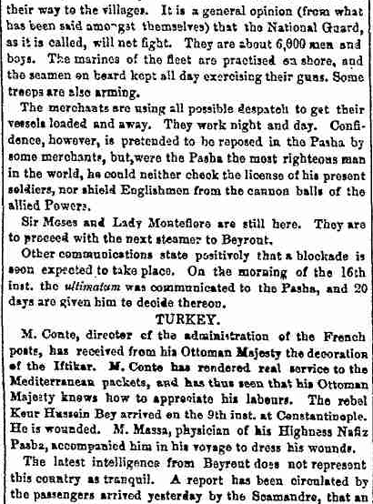
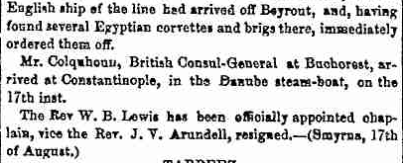
Clearly the evidence says that the ultimatum was not delivered to the pasha as he was absent when the ship arrived on the 11th of August and it was not delivered to the pasha until the 16th of August 1840.
Uriah Smith and At Jones both say that the fulfillment of the sixth trumpet happened on the 11th of August 1840 because on that day the sultans envoy delivered an ultimatum to the Pasher of Egypt from the 4 christian powers. According to the above newspaper reports this did not happen until the 16th of August as the Pasher was absent from Alexandria when they arrived on the 11th of August so it was not delivered to him on that day. Other reports say that the ship was quarantined until the 16th of August making it impossible for the ultimatum to be delivered until that date.

